**Group Assignment**

**(Batch 1)**

**Topic: SQL fundamentals Retrieving Data Using the SQL SELECT Statement, Restricting and Sorting Data​**

**Team members:**

* **Rahul Veer Singh**
* **Ashwini Janthe**
* **M. Maneesha**
* **Rishabh Singh**
* **Madhurima Nidhi Sree K**
* **Ujjwal Pandey**

**Tables:**

1. **Rahul’s table:**

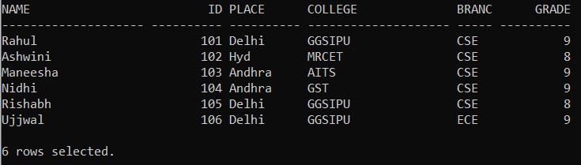

1. **Rishabh’s table:**

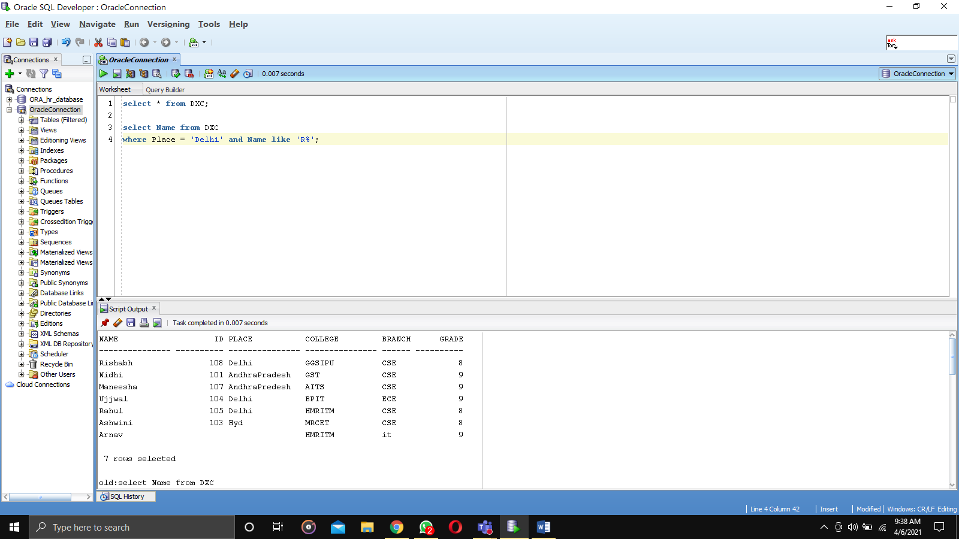

1. **Madhurima’s table:**

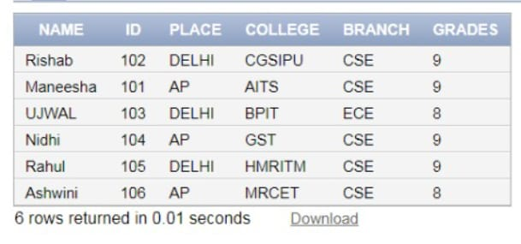

1. **Maneesha’s table:**

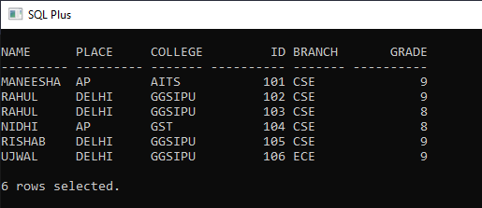

1. **Ashwini’s table:**

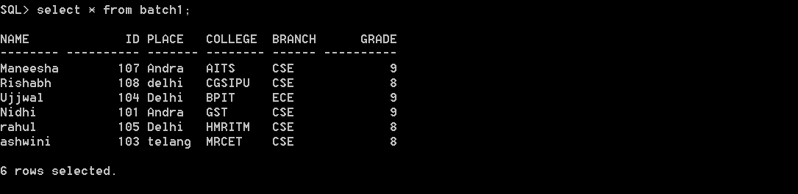

1. **Ujjwal’s table:**

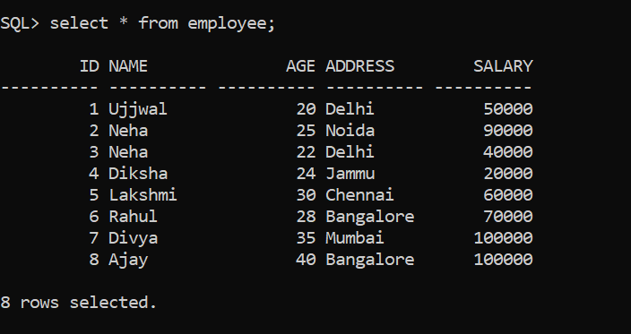

**Commands and Outputs:**

1. **Rahul’s Commands:** Restricting dataof table with the use of ‘WHERE’ clause

* **ARITHMETIC OPERATIONS:** select * from DXC where ID = 101;

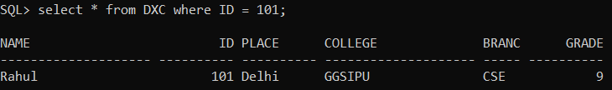

* **ARITHMETIC OPERATIONS:** select * from DXC where grade<9;

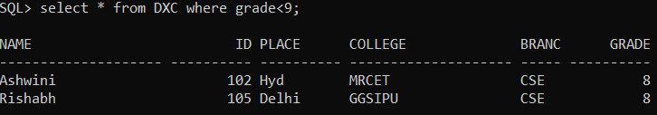

* **ARITHMETIC OPERATIONS:** select * from DXC where grade>8;

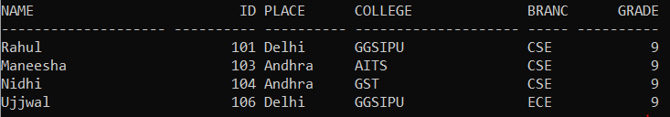

* **ARITHMETIC OPERATIONS:** select * from DXC where ID != 104;

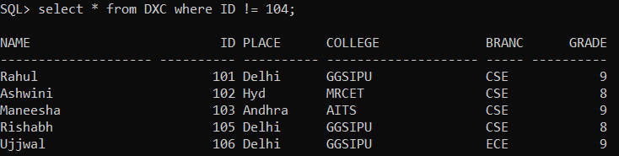

* **BETWEEN:** select * from DXC where ID between 102 and 104;

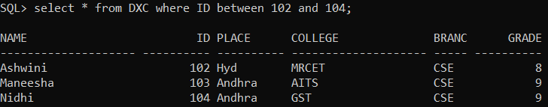

* **IN:** select * from DXC where ID in (102,104);

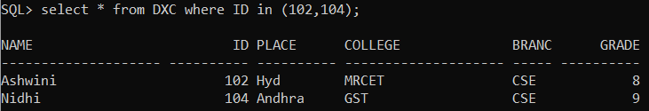

* **LIKE (PREFIX):** select * from DXC where COLLEGE like 'GGS%';

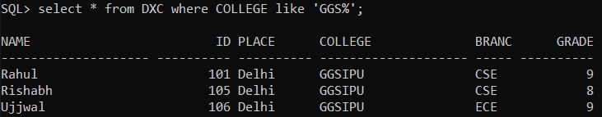

* **LIKE (BASED ON SECOND LETTER):** select * from DXC where COLLEGE like '_I%';

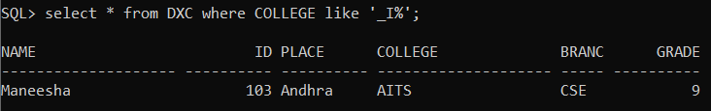

* **LIKE (SUFFIX):** select * from DXC where COLLEGE like '%T';

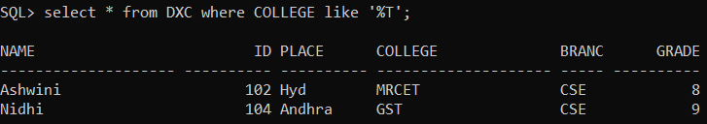

1. **Rishabh’s Commands:** use of logical operators in table operations

* **AND:** select Name from DXC where Place = 'Delhi' and Name like 'R%';

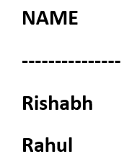

* **OR:** select Name from DXC where Place = 'Delhi' or Name like 'R%';

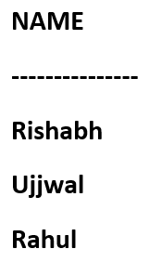

* **NOT:** select Name, College from DXC where not (id is null) and not (place = 'Delhi');

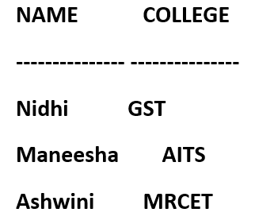

1. **Madhurima’s Commands:** use of comparision operators in table operations

* **COUNT:** select count(*) as no_of_students_with_grades_9 from dxc where grades=9;

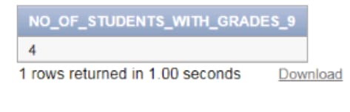

* **LIKE (SUFFIX):** select * from dxc where branch like 'E%';

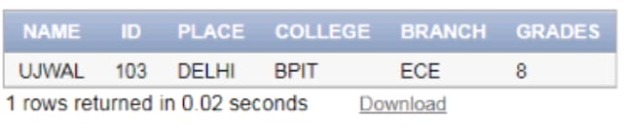

* **LIKE (FOR 5 LETTER NAME):** select * from dxc where name like '_____';

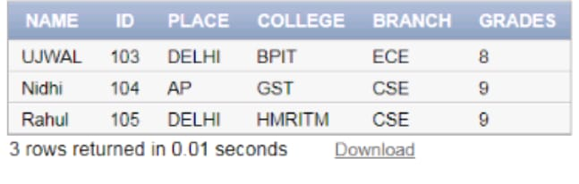

* **NOT EQUAL:** select name from dxc where id <> 105;

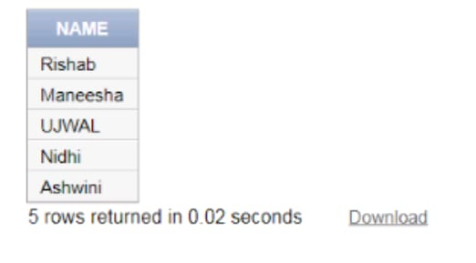

* **LESS THAN AND EQUAL TO:** select * from dxc where grades<=8;

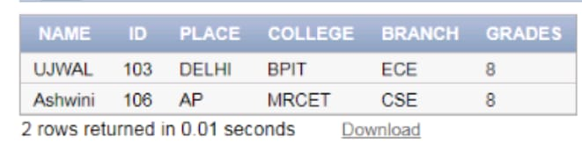

1. **Maneesha’s Commands:** use of SELECT statement in table operations

* Selecting everything from table:

SELECT * FROM DXCB1;

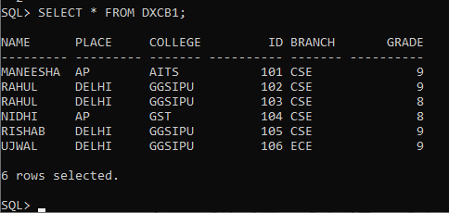

* Selecting ID, College and Branch from table:

SELECT ID, COLLEGE, BRANCH FROM DXCB1;

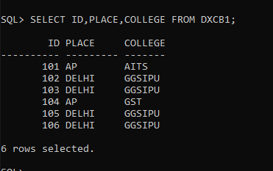

* Selecting place and grade from the table:

SELECT PLACE, GRADE FROM DXCB1;

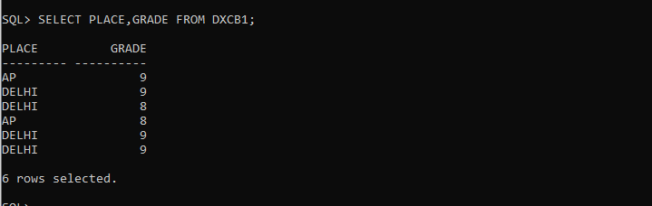

1. **Ashwini’s Commands:** Sorting dataof table with the use of ‘ORDER BY’ clause

* **DESCENDING ORDER:** Select * from batch1 order by place desc;

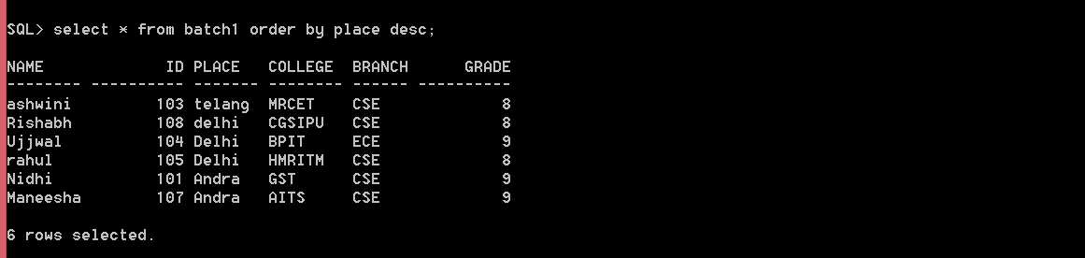

* **ASCENDING ORDER:** Select * from batch1 order by place asc;

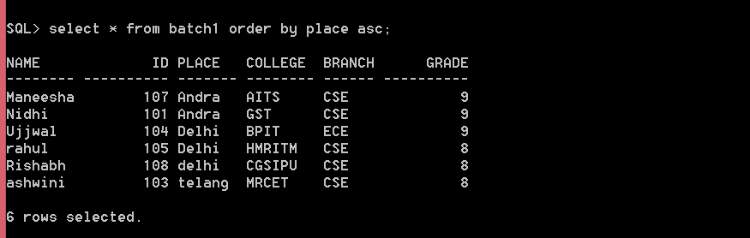

* **SORT ACCORDING TO MULTIPLE COLUMNS:**

Select * from batch1 order by place desc, college asc;

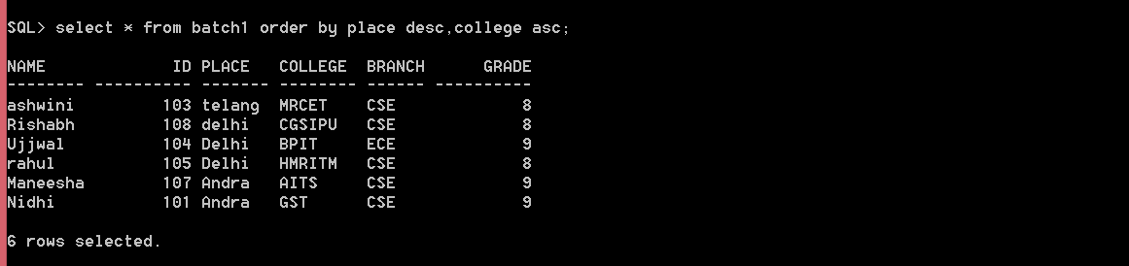

1. **Ujjwal’s Commands:** use of subqueries using SELECT statement in table operations

* **To select the information about all the employees who have a salary >50000:**

select * from employee where id in (select id from employees where salary>50000);

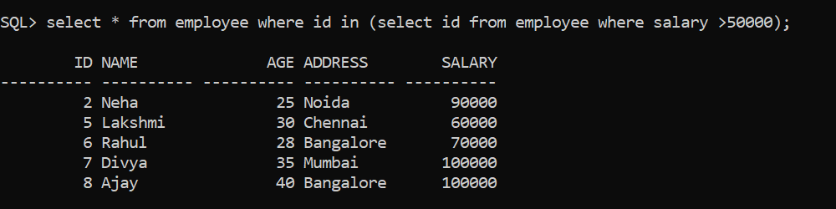

* To select Id, Name, Age of all the employees who are living in either Mumbai or Chennai.

select Id, Name, Age from employee where address in (select address from employee where address='Chennai' or address='Mumbai');

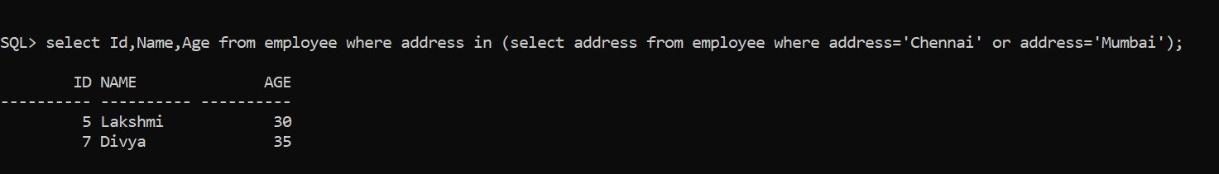

* To select the minimum salary from employees

select * from employee where salary = (select min(salary) from employee);

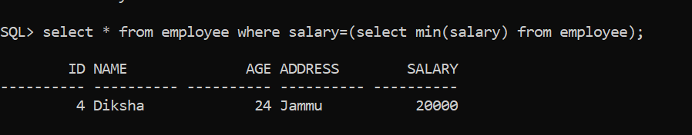

* To use select subqueries with update statement to increase the salary of the employee with the maximum age.

update employee

set salary=salary*2

where age = (select max(age) from employee);

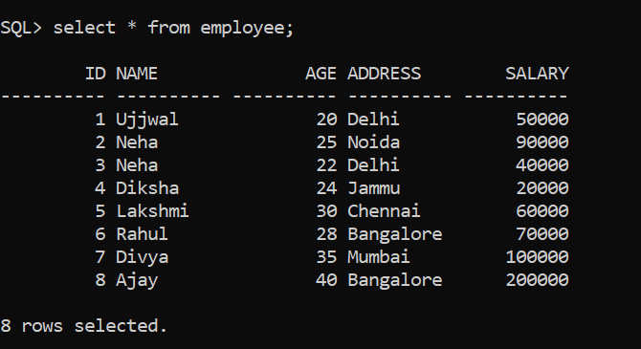

* To show the details of that employee who have the maximum salary in the table using subqueries.

select * from employee where id = (select id from employee where salary = (select max(salary) from employee));

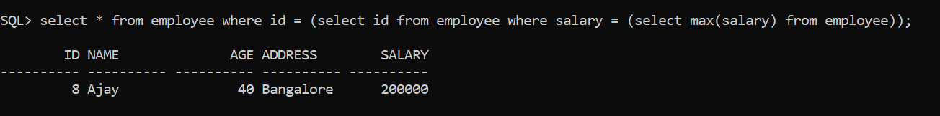

* To select distinct address from employee.

select distinct(address) from employee;

